Here Comes the Sun: Water Hydrolysis and its Connection to Solar Energy
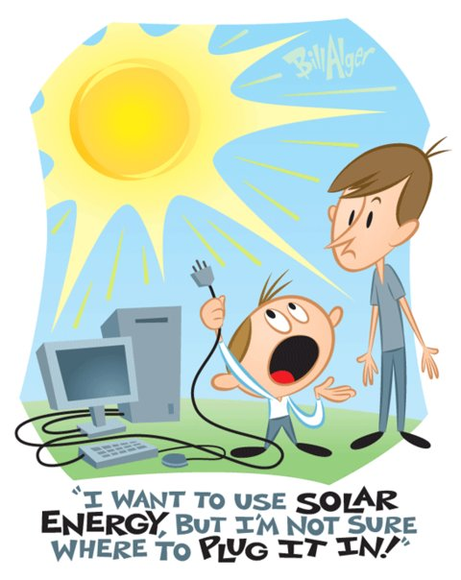
"The Sun, the hearth of affection and life, pours burning love on the delighted earth."
—Arthur Rimbaud (1854–1891)

Document Overview: This lesson plan is designed to introduce students to the work of Harry Gray. Students investigate hydrolysis through an inquiry lab. Then they will connect their lab experience to the potential of solar energy and hydrogen as energy storage.

Minnesota State Academic Science Standards:

7.1.1.2.1
Generate and refine a variety of scientific questions and match them with appropriate methods of investigation, such as field studies, controlled experiments, reviews of existing work, and development of models.

7.2.1.1.3
Recognize that a chemical equation describes a reaction where pure substances change to produce one or more pure substances whose properties are different from the original substance(s).

8.1.3.3.2
Understand that scientific knowledge is always changing as new technologies and information enhance observations and analysis of data. For example: Analyze how new telescopes have provided new information about the universe.

8.1.3.3.3
Provide examples of how advances in technology have impacted the ways in which people live, work and interact.

9.1.1.1.6
Describe how changes in scientific knowledge generally occur in incremental steps that include and build on earlier knowledge.

9.1.3.2.2
Analyze possible careers in science and engineering in terms of education requirements, working practices and rewards.

9.2.1.2.3
Describe a chemical reaction using words and symbolic equations. For example: The reaction of hydrogen gas with oxygen gas can be written: 2H₂ + O2 → 2H₂O.

9.2.3.2.1
Identify the energy forms and explain the transfers of energy involved in the operation of common devices. For example: Light bulbs, electric motors, automobiles or bicycles.

9.2.4.1.1
Compare local and global environmental and economic advantages and disadvantages of generating electricity using various sources or energy. For example: Fossil fuels, nuclear fission, wind, sun or tidal energy.

Objectives:
Students will be able to describe how water can be split and used as an energy source.
Students will be able to describe the chemical reaction of hydrolysis.
Students will be able to discuss how to advance solar energy to a point that we can use it on a larger scale.

Type of Activity: Inquiry Lab

Duration: 50 minute class for Inquiry Lab, Optional 2nd day: Discuss creating technology to support renewable resources. This lab will connect the collection of hydrogen using solar energy to the conversion of solar energy to chemical energy.

Connection to Nobel speakers:
Harry Barkus Gray is the Arnold O. Beckman Professor of Chemistry at California Institute of Technology. He won the Priestley Medal in 1991, Harvey Prize in 2000, The Benjamin Franklin Medal in Chemistry in 2004, and the Wolf Prize in Chemistry in 2004. He was inducted into the Alpha Chi Sigma Hall of Fame in 2012. In 2013, he received the Othmer Gold Medal, for outstanding contribution to chemistry and science.

Dr. Gray's interdisciplinary research program addresses a wide range of fundamental problems in inorganic chemistry, biochemistry, and biophysics. Electron transfer (ET) chemistry is a unifying theme for much of this research and involves studying electron movement from one atom or molecule to another atom or molecule. Dr. Gray’s goal is to make Solar Power more efficient by incorporating Earth abundant materials that are non-toxic and cost effective. In doing so, we could power our planet with Solar Fuel, become energy independent, and protect our environment.

Teacher Tips:
Dr. Gray is a proponent of solar energy. Solar energy faces a few challenges. One rather large challenge is storing the energy collected by solar panels for use at times other than mid-day. Dr. Gray proposes using solar energy for a process called electrolysis. Electrolysis is the separation of molecules of H₂O into molecules of H₂ and molecules of O₂ gas. This allows for storage of the energy collected by the solar cells. When the stored energy is to be used, the gases flow through the hydrogen or oxygen path of a fuel cell and are allowed to recombine. When the hydrogen crosses a membrane within the fuel cell, charges move and provide an electrical current and water. No greenhouse gases or other pollutants are produced.

This lab investigates electrolysis by having students electrolyze water using a 9 volt battery as an energy source. If solar cells and a sunny day are available, one could attempt to replace the 9V battery with solar panels (expect this to run at a much slower pace). If solar cells aren’t available or if the weather isn’t ideal, explain to students that Dr. Gray would use solar cells in place of 9V batteries.

The lab can be set-up in one of two ways. It is best with a battery clip, as the battery can be taped to the side of the pop bottle and just the wires placed in the water. If battery clips are not available, students can hold the cup on top of the battery terminals to split water. The bottles/cups do leak water. To prevent them from leaking, the nails could be sealed with silicon or hot glue. If time is a constraint, one could skip this step and have students clean water off tables when they are done as it is not a lot of water.

Chemical reaction of hydrolysis:
When electrical energy is introduced to water, the molecular bonds are broken and energy is released. This energy is transformed into chemical potential energy when two hydrogen atoms from a hydrogen molecule and when two oxygen atoms combine to form an oxygen molecule.

The pictures will assist in helping students set-up the lab. Students should draw a diagram of the set-up with labels in their lab report.

Note: Some commercially available products include a chamber in which electrolysis occurs and the gas is sent directly to a fuel cell. These products typically use more expensive electrodes and require distilled water. If you are using one of these commercially available products, please follow the manufacturers instructions regarding the use or avoidance of electrolytes.

Extensions of lab can be done by using a small solar cell on a sunny day, or using heat lamps at different angles, thus providing the connection to the solar energy and hydrogen power. Students can also experiment with different electrolyte solutions to see if the solution changes the amount of hydrolysis that occurs. Hydrogen gas in the test tube could also be identified using a glowing splint. Additionally, the purity of the water, the electrolytes used, and the metal probes used as electrodes placed within the test-tubes will all affect the rate of electrolysis and what other substances are seen to gather at the tips of the electrodes. These can be interesting questions to investigate.

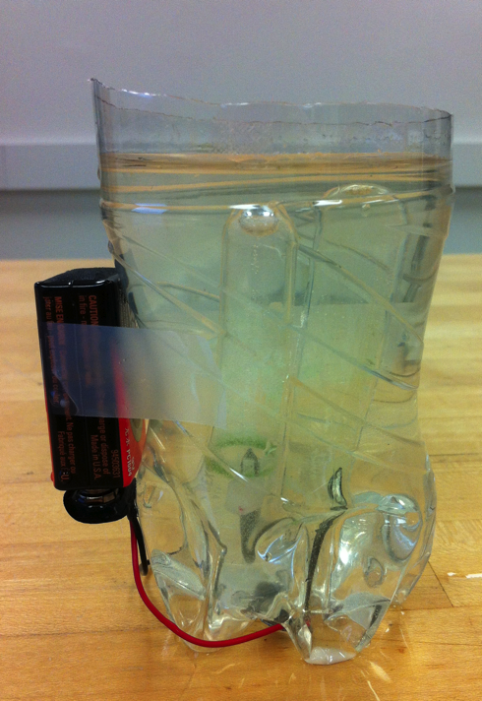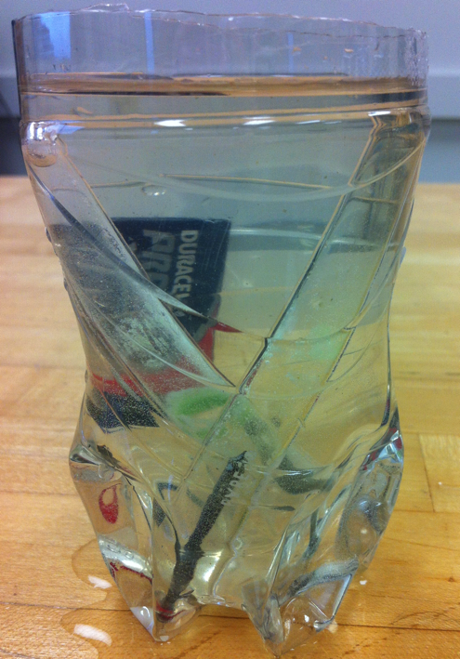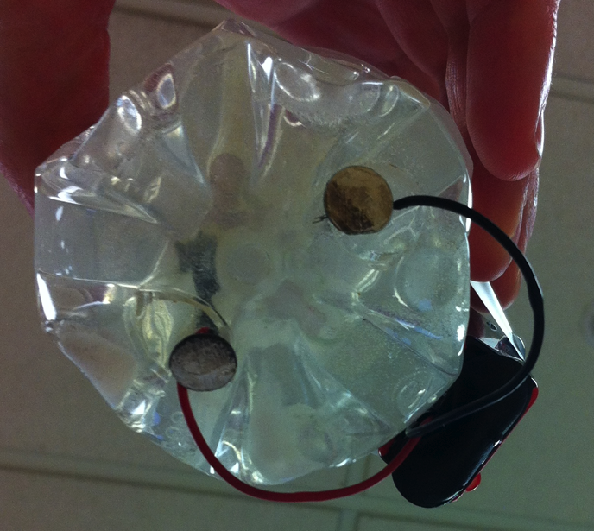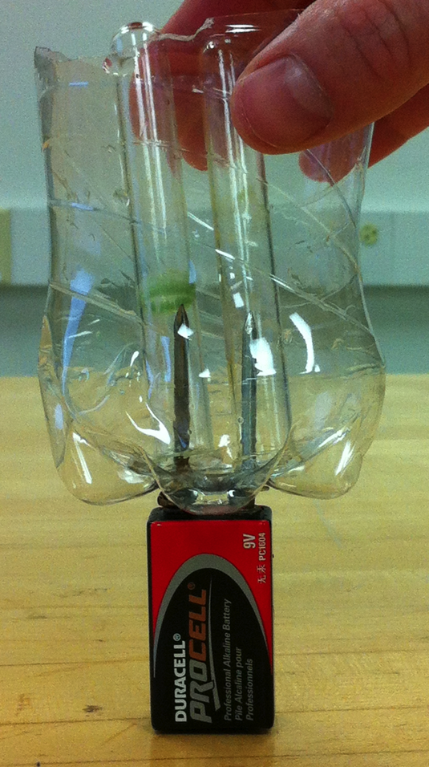

Concepts and Keywords:

Hydrolysis
Electrolysis
Water Splitting
Solar Energy
Chemical Energy
Electrolyte
Photosynthesis
Energy

Materials for Inquiry Lab:
½ clear 16oz pop bottle  2 galvanized nails  2 small glass test tubes  9V battery | battery clip  250ml water  two teaspoons of baking soda  stopwatch

Overview of Lesson:
Students will use the energy from a battery to split water into hydrogen and oxygen. When water is split energy is stored in the resulting gasses that can be recovered later. When the hydrogen and oxygen are recombined, energy is released. Scientists are interested in developing this process to make it affordable, efficient, and use it as a storage medium for renewable energy sources. Much like plants do, by collecting energy from the sun using solar cells and storing the energy for future use, people may become less dependent on nonrenewable resources in the future.

Additional Resources:
Articles:
Excerpt from “The last hours of ancient sunlight: we’re made of ancient sunlight” By Thom Hartmann
http://www.thomhartmann.com/blog/2007/11/last-hours-ancient-sunlight-were-made-out-ancient-sunlight#sthash.H0SQSFdh.dpuf

Solar Powered Fuel Cells Article
An M.I.T. researcher thinks he's found a way to efficiently use solar power to drive the electrolysis of water, which would isolate hydrogen for fuel cells.
http://www.scientificamerican.com/podcast/episode/7e5d4fd8-fc46-ceea-89bea7c1dc65e2f5/

A new Dawn for Solar Energy Article
http://www.popsci.com/environment/article/2008-08/new-dawn-solar-energy

Cars and Hydrolysis Article
http://www.caranddriver.com/columns/a-fuel-cell-car-that-works-hydrolysis-page-2

Labs that support the lab ideas above that could be used as extensions or alternatives:
Cal-Tech Water Splitting Lab
http://sunlight.caltech.edu/mrose/Lesson-Plan_H2-from-H2O_WaterSplitting_CP_120310.pdf

Water Splitting Experiments
http://www.reachoutmichigan.org/funexperiments/agesubject/lessons/energy/split_h2o.html

Water Electrolysis
http://wwwo.education.com/science-fair/article/water-electrolysis/

Solar Energy Information- Mini Labs
http://www1.eere.energy.gov/education/pdfs/solar_sunenergy.pdf

Using splitting of hydrogen and solar power to create energy
http://hypersolar.com/technology.php

Video:
Overview of Harry Gray’s Research
http://www.youtube.com/watch?v=5POW__phQfM

Harry Gray and his research
http://www.youtube.com/watch?v=fwqVsRLHq24
Inquiry Lab: H₂O Hydrolysis

Name: Date: Class Hour:

H₂O Hydrolysis

What is the future of energy? Scientists are excited about the idea of harvesting energy from the sun to break apart water molecules. Water is a chemical with the molecular formula H₂O. Each molecule of water is made of 2 hydrogen atoms and 1 oxygen atom. When an electrical current passes through water it can be split into the 2 different atoms in a process called hydrolysis.

The products of hydrolysis are hydrogen and oxygen molecules that store chemical potential energy in the bonds of the molecules. The hydrogen “fuel” is then used for any electrical energy application. The practical use of this technology is beset with difficulties as solar panels are expensive, inefficient, and made with rare Earth metals. Scientists are working on ways to make solar cells that are inexpensive, durable, and non-toxic. The hydrogen and oxygen molecules that are produced from water that is split can be stored. Then they can later be recombined to generate electricity to do work.
The process of hydrolysis can be demonstrated using a battery or solar cell as an energy source. The positive and negative terminals are placed separately yet near one another under water to cause the water to electrolyze into hydrogen and oxygen gasses.
Why is this technology so exciting? Researchers are hoping to mimic plants and their ability to use the sun to split water and create chemical energy. They are working on ways to create solar cells that can collect and store energy in large amounts to power our homes and other devices that use electricity.
This lab will investigate a process that can be used to split water (hydrolysis- “hydro” refers to water and “-lysis” refers to splitting apart) that ideally could be put back together to release chemical energy. Pure water is not a good conductor of electricity so we will create an electrolyte solution (baking soda and water). An electrolyte can be broken apart in a process called electrolysis (“electro” refers to energy and electricity). Electrolytes are important in batteries as well as in transferring energy in our body.

Pre-Lab Reading:
Write and define 6 words above.

Name: Date: Class Hour:

Title: H₂O Hydrolysis

Purpose: What happens when an electrolyte solution is connected to an energy source?

Hypothesis: I think…

because…

Materials:
½ clear 16oz pop bottle  2 galvanized nails  2 small test tubes  9V battery | battery clip  250ml water  two teaspoons of baking soda  stopwatch

Procedure:
- Cut off the top of the pop bottle
- Insert the nails into the bottom of the bottle so the points push up into the container.
- Space them so they are the same distance apart as the 2 terminals of the 9V battery.
- Wrap the red wire of the battery clip around one of the nails. (Note: if not using the battery clip, the cup will be balancing on top of the 2 nails)
- Wrap the black wire of the battery clip around the other nail.
- Tape the battery to the side of the cup. Do not connect the battery to the clip yet..
- Fill the pop bottle with the baking soda water (electrolyte solution)...about 250ml of water with a bottlecap (4g) of baking soda
- Fill the test tube to the top with baking soda water (electrolyte solution)
- Put your thumb over the top of the test tube. Flip the test tube so it is upside down. Carefully submerge the test tube under the water in the pop bottle. Remove your finger. Place test tube over the nail. There should be no air in the test tube.
- Repeat with the second test tube and place over the other nail.
- Attach the battery clip to the battery.
- Measure the amount of water in the test tube every minute. To take your measurements you will place the ruler next to the test tube and measure the air bubble in mm.
Photo of Set-Up:

Data:

Time (min) | Nail 1  Quantitative  Observations  (mm) | Nail 1  Qualitative  Observations | Nail 2  Quantitative  Observations  (mm) | Nail 2  Qualitative  Observations
0
1
2
3
4
5
6
7
8
9
10

Data Analysis:
- Which nail produced the larger air bubble? Give numerical data.
- Does this air bubble represent the hydrogen or the oxygen?
- Why?
- Which battery terminal produced the larger air bubble? Positive or Negative
- Which nail produced the smaller air bubble?
- Does this air bubble represent the hydrogen or the oxygen? Give numerical data.
- Why?
- Which battery terminal produced the smaller air bubble? Positive or Negative
- How does this data represent a molecule of water?

- Write the chemical equation to represent the reaction that took place in the lab.

- Draw the Lewis Dot structures to represent the equation above.

- Why is splitting water useful?

- What happens when the hydrogen and oxygen are recombined to form water?

- Why is this considered a renewable resource?

Conclusion: (write in full sentences)

What evidence was collected?

How does the data collected support your hypothesis?

What might be the scientific reason for the outcome of the investigation?

What did you learn in this investigation?

